TRẦN MINH ĐỨC – ITCSIU24022

EXERCISE 1: SETUP AND DISPLAY (15 points)

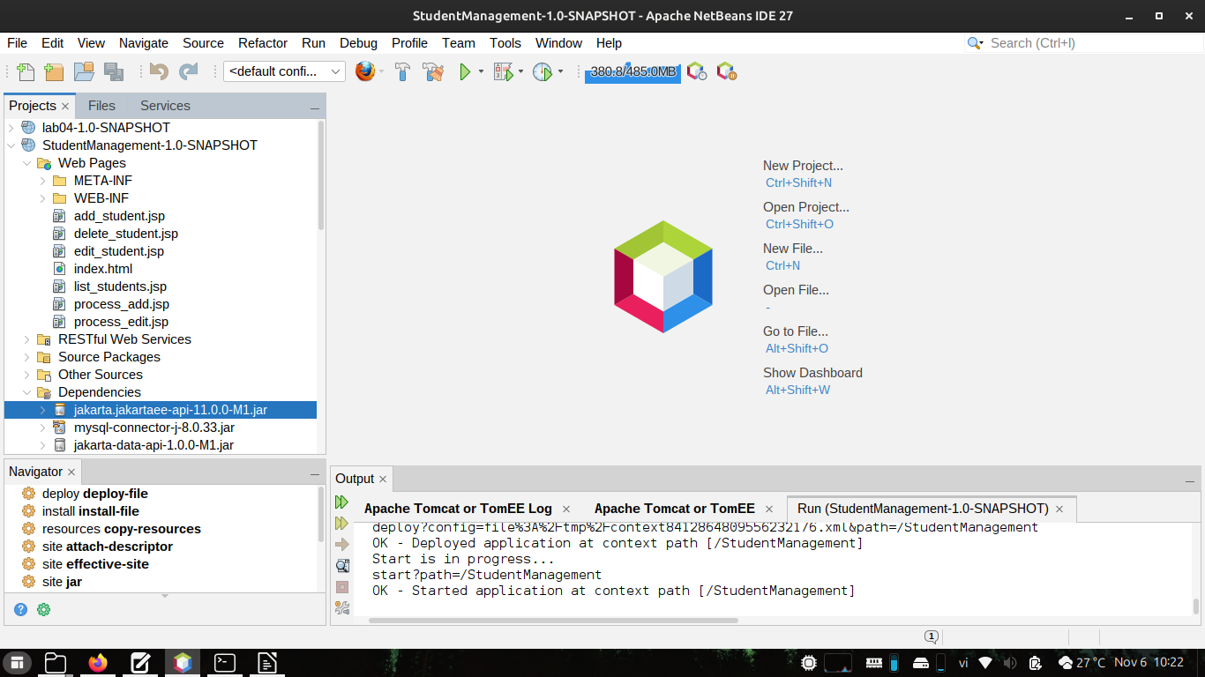
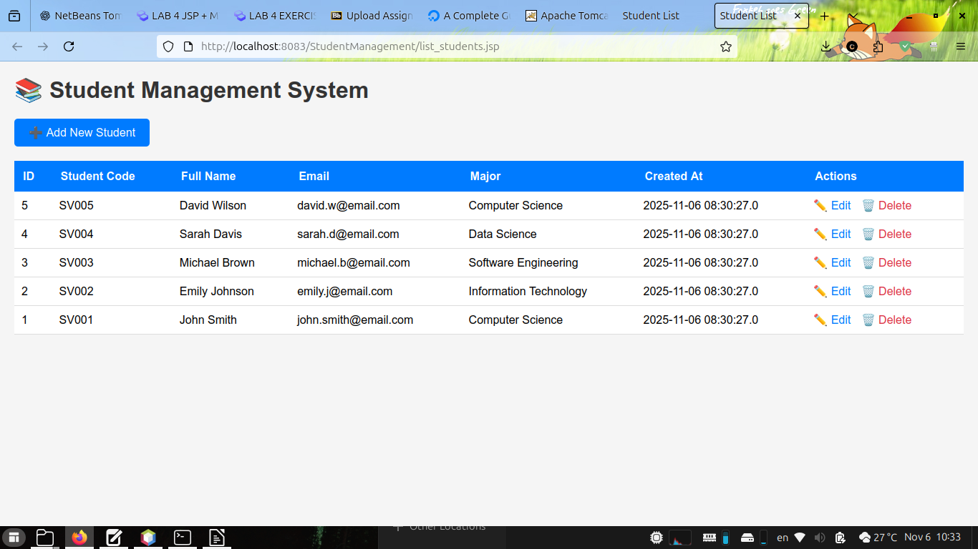
EXERCISE 2:

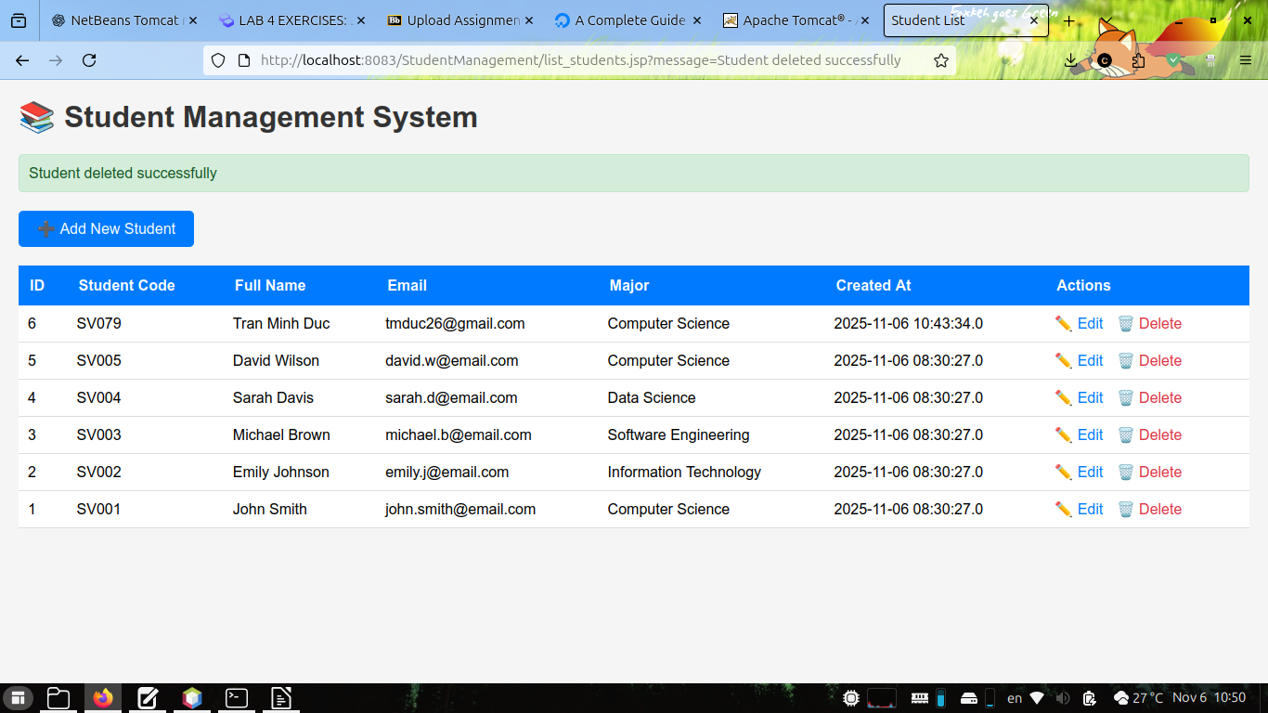
When clicking “Adding New Student”, it will redirect to “add_student.jsp” where users are required to input the name, email, major and student code.

In development side, instead of bumping to the real page, it will evoke “process_add.jsp” and all inputs are stored into constant variables

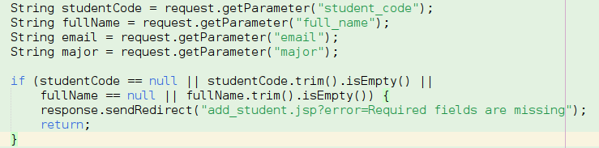
Check whether each fields is empty, ?error=Required fields are missing : Raise error “Required fields are missing”.

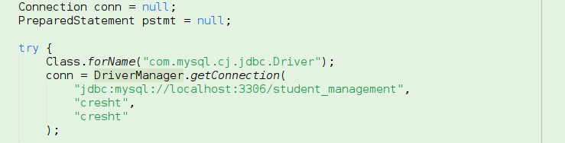
Declare Connection: Connection conn = null;
Load Driver: Class.forName()
Locate The Database Of Local User: DriverManager.getConnection()
Prepare the SQL statement with “String sql = “INSERT INTO students (student_code, full_name, email, major) VALUES (?, ?, ?, ?)””

Use the setString to modify the values
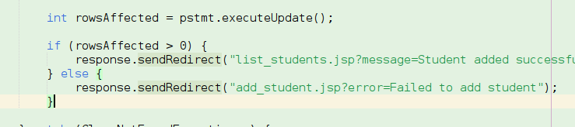
response.sendDirect(“..”) : Retrieve the previous website if successfully, otherwise raise error

EXERCISE 3: UPDATE OPERATION

When clicking edit upon specific row (ID), it will proceed edit_student.jsp with the form display

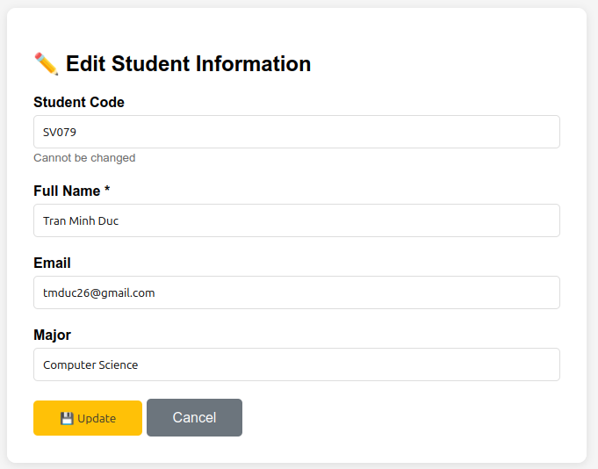

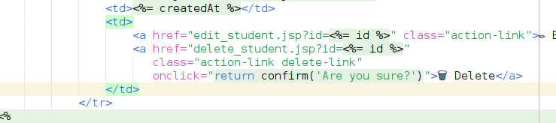
Initial conditions: Check if the student ID is valid, otherwise it will redirect to list_students.jsp with an error “Invalid student ID”

Declaring the variables for modification
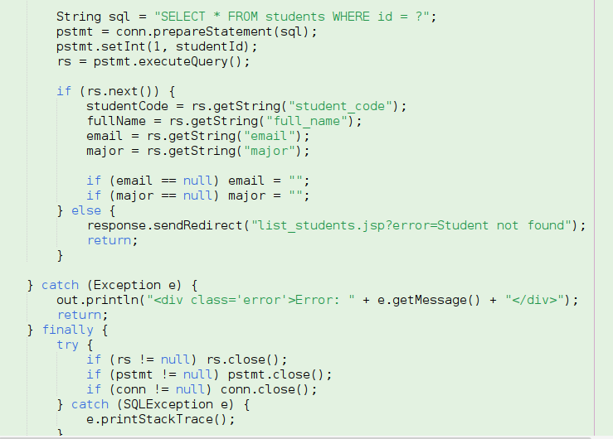

rs = pstmt.executeQuery(): Establish the query selection with respective ID

rs.next() : while the string is not null, evoke the getString() to each variables: studentCode, fullName, email, major – If email – major fields are empty → return empty.

Proceeds to close the connection

When typing Update, it will run process_edit.jsp and apply all changes to the list_students (similar to insertion)

EXERCISE 4: DELETE OPERATION

When clicking Delete on respective ID (row), it will prompt an alert of deletion, if yes – it will redirect to delete_student.jsp, get parameter of the ID, then proceed to execute the DELETE FROM QUERY and executeUpdate();

If successful, it will return back to list_students.jsp – otherwise prompt an error of database, or student not found.
